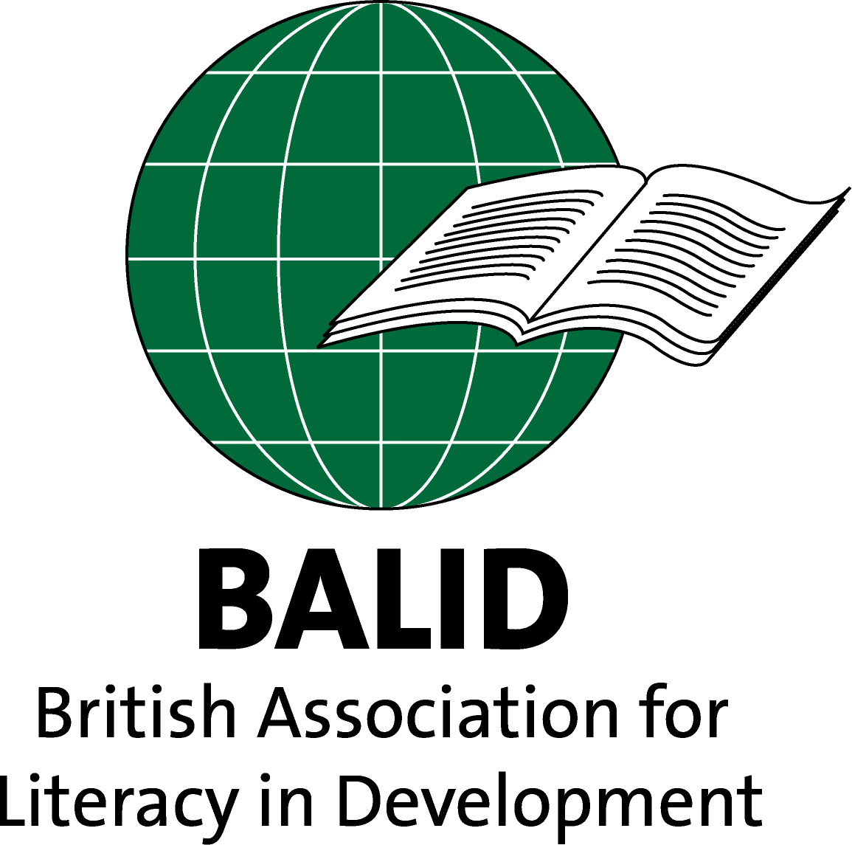

**Annual Report 2016 – 2017**

**AGM 5th December 2017 at 14.00**

**24 Tufton Street, Westminster**

**London, SW1P 3RB**

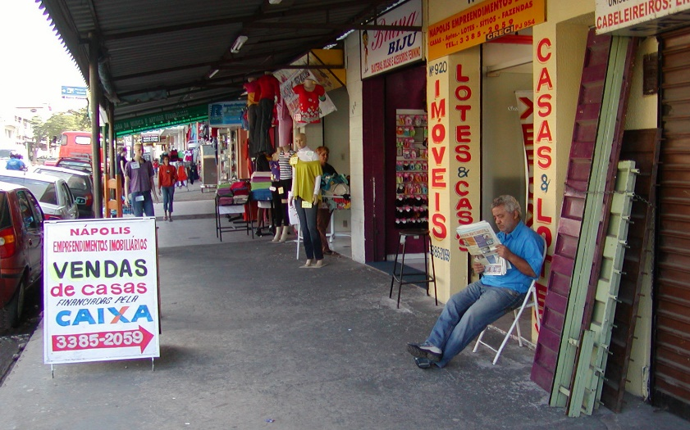

**Literacy in Brazil (photo: Brian Street)**

**from**

**Theory and Practice in Literacy and Development:**

**Papers from the BALID Informal Literacy Discussions 2011-2015**

**Second Edition 2017**

# Introduction

This report describes BALID’s activities in the year 1st September 2016 to 31st August 2017 and includes reports on our *Weaving Literacy through Lifelong Learning* seminar, our Informal Literacy Discussions and our finances. Sadly, we also have to report that we lost our much-loved and respected President, Prof. Brian Street, who died in June.

# A Tribute to Professor Brian Street, President of BALID

# b. 1943 – d. 2017

BALID, like many other organisations, owes a great deal to Brian, who died on 21 June 2017. I was privileged to see him several times in the weeks before he died. For 15 years he had kept his illness quiet and carried on with his research, his writing, his teaching and his support for others. He rarely talked about himself.

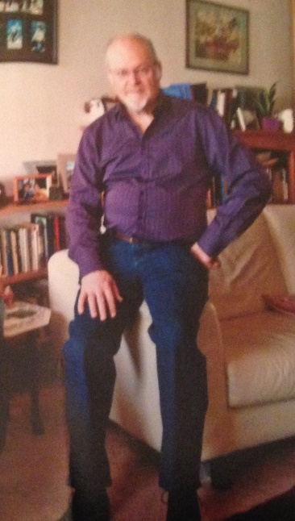Brian rarely spoke of his early years, and his background was not one which might suggest he would become a leading authority on adult literacy, if not **the** leading authority. He was born in Manchester and the family moved to Devon. When working at 18 he had a very serious accident which permanently damaged his eye. He went to Buckland University Hall, where he obtained an English Literature degree and then to the University of Oxford to do a diploma in Anthropology before progressing on to a PhD. Literature and Anthropology were combined in his first book *‘The Savage in Literature’* (1994), republished in 2016.

His interest in literacy began when he became stranded in Iran while travelling to Afghanistan, a popular journey for adventurous young people at the time. There he began to notice the disjunction between the literacy and numeracy used in the community and that taught formally in school. He returned to Iran in 1970 to study this in more depth. The result of his research was to challenge the “Great Divide” (Goody 1977, Olson 1977), a theory which links the acquisition of literacy to higher-reasoning processes and thus divides literate and non-literate people into developed and underdeveloped peoples, paralleling the Darwinian concept of evolution. Brian’s great contribution is the theory of social literacies, the literacies used in everyday life. He argued that these should form the basis of literacy taught to adults. His publication ‘*Literacy in Theory and Practice’* in 1984 led to the concept of literacies and social practice, New Literacy Studies (NLS) and later to LETTER (Learning Empowerment through Training in Ethnographic Research) – in other words, to new ways of learning and teaching literacy and of developing materials. These methods have been adopted by many literacy schemes. However, measuring learning attainment becomes complex when people learn what they want to learn and not what the government thinks they should learn, and this impacts on funding.

Brian taught for 22 years at the University of Sussex where he met his first wife, Joanna, with whom he had three children, and then from 1996 at King’s College, London. In 1998, he started working at the University of Pennsylvania as a visiting professor and later at the Universidade Federal de Minas Gerais in Brazil, where he met his second wife, Maria Lucia Castanheira. He authored, co-authored, or edited 30 books and published over 150 articles or chapters of books. He received a number of major honours.

I first met Brian over 40 years ago in Brighton when a mutual friend, who knew I worked in literacy at the Friends Centre, introduced us. Brian was a continual support from then on. When I did my PhD at Sussex University on attitudes to literacy and education among Gypsies and Travellers, Brian was working in London and though not my official supervisor, he advised me throughout. When I had collated all the evidence his final comment was “So what?” which hit the nail on the head as I had not thought about the theoretical implications.

Brian was always willing to help, always willing to listen and I never heard him argue. He was a remarkably modest man. Despite his research and his teaching, as President of BALID he was always involved in the detail of our work. He came to all the committee meetings, conferences and seminars we held and was fully involved in our work including a conference at the University of Cape Town, South Africa, in 2011 with PRAESA, a South African NGO. Brian was an exceptional person as well as an exceptional academic.

*Juliet McCaffery*

References

Goody, J. (1977). *The Domestication of the Savage Mind.* Cambridge: Cambridge University Press.

Olson, D. R. (1977). ‘From utterance to text: The bias of language in speech and writing.’ *Harvard Educational Review,* 47, pp 257–281.

# Report from the Chair

The last year has been marked by a wealth of BALID activities and also the sad loss of Brian Street, our President, in June. Brian was an immensely active President, inspiring us all with the generous way he shared his academic curiosity, wide network of contacts and publications. Conversations with Brian have been a valuable feature of BALID events, both during and over a glass of wine afterwards.

The year started in November 2016 with *Weaving Literary through Lifelong Learning,* in partnership with University College London (UCL) Institute of Education (IoE). This was one of the highest profile events which BALID has hosted in recent years with a keynote presentation from Dr Ulrike Hanemann from UIL, who took opportunity to share her lifelong literacy framework incorporating three dimensions: literacy as a lifelong process, literacy as a lifewide process, and literacy as a sector-wide and cross-sector process. This provided a framework for the rest of the day in which researchers and practitioners shared their perspectives. There were six new faces at this event, including five PhD students kindly sponsored by BAICE. A longer report is included below, together with links to video footage from this inspiring day.

Our AGM in December was quiet, in comparison to *Weaving Literacy*. However*,* it was followed by a stimulating Informal Literacy Discussion (ILD) led by Tara Furlong on her research into Literacy in Professional Services. One of the highlights of the ILDs is the range of topics covered and the opportunities to make connections, in this case, between supporting those developing quite complex literacies for engagement in professional services with those developing literacies for life in resource-poor contexts. The ILD programme has continued throughout the year with ILDs taking place in January on Training Literacy Facilitators in Tanzania, led by Margaret Beckett of SIL; in April on Literacy Teaching in Northern Nigeria led by Mary Anderson; in June on learner-generated materials and collective classroom knowledge in Guatemala, led by Marta Paluch, (who is undertaking a PhD at Sussex University) and in November on Literacy with the San, Nambia, led by Candi Miller. More details on these events is included later in this report and also on the BALID website (www.balid.org.uk). In August 2017, a second edition was printed of *Theory and Practice in Literacy and Development.* This book, which consists of accounts of 12 ILDs and is available free on the BALID website, has been well received and plans are being made for a second volume.

In addition to the BALID events, individual members have been involved in a wealth of initiatives including working with the UNESCO Institute for Lifelong Learning (UIL) on the development of a resource pack on intergenerational approaches to literacy teaching and learning, ‘*Learning Together Across Generations: Guidelines for Family Literacy and Learning Programmes for Lifelong Learning’*. Details of other publications are included in this report, following the profiles of committee members.

The BALID committee has been active throughout the year, meeting before every ILD and coordinating events by Skype and email. We have revisited our vision and mission statements. Each member of the committee has taken on specific roles, which contribute to the success of BALID as a whole. Special thanks are due to Juliet McCaffery (secretary), Mary Anderson (ILDs and social media), Tara Furlong (IT and link person with RaPAL), and Ian Cheffy (treasurer). We are delighted to have Alan Rogers on the committee for his wealth of experience, contacts, feedback and excellent ideas. Finally, Marta Paluch has agreed to join the committee and will, hopefully, be confirmed as a member at the AGM in December 2017. Marta will bring fresh energy and ideas as well as expertise on literacy in Latin America. BALID continues to liaise with other organisations including the University of East Anglia, BAAL and BAICE. We have also started working more closely with Research and Practice in Adult Literacy (RaPAL) with committee members facilitating a workshop at the RaPAL conference in Liverpool and RaPAL inviting BALID to contribute to their publications.

As we look ahead to the coming year, I am delighted to report that BALID is on a stronger financial footing than in recent years. We have ambitious activities planned for the year ahead which includes ILDs from academics and practitioners, an awayday to share how the work of Brian Street on literacy as social practice has influenced our own work and, on International Literacy Day, 8 September 2018, a colloquium to celebrate Brian’s contribution to BALID.

We hope you will join us at some, or all, of these events and continue to raise the profile of literacy in development.

*Katy Newell-Jones*

# Report from the Secretary

The 2016-2017 financial year ended 31st August 2017. The officers for the next three year triennium were elected at the 2015-2016 AGM on 28th Nov 2016.

Committee meetings were held regularly through the year and usually In London, though one was held in Brighton, which was followed by an ILD led by Marta Paluch, a PhD student from the University of Sussex which attracted 5 people from the local area who had not previously attended a BALID event. A couple of meetings were held using Skype, partly due to people’s availability and partly to save committee members’ travel costs. The dates of the meetings are listed below. Meetings were well attended and the minutes of all meetings are available from the Secretary.

Committee meetings were held on 2nd November, 2016, in London, on 9th January on Skype, on 24th January and 20th April in London, on 30th May on Skype, on 12th June in Brighton and on 25th July in London.

The committee meetings addressed a wide range of issues, including BALID’s strategic aims and future direction, an audit of members’ skillsand seminars including *Weaving Literacy through Lifelong Learning*. A second edition of ‘*Theory and Practice of Literacy in Development: Papers from the BALID Informal Literacy Discussions 2011-2015* was published.

The committee successfully applied for a UIL consultancy and Juliet and Katy worked with UIL in Hamburg to produce ‘Learning Together Across Generations: Guidelines for Family Literacy and Learning Programmes for Lifelong Learning’.

The considerable costs incurred by committee members for travelling to meetings were reviewed and at the meeting on 24th January it was decided that the travel expenses of committee members should be reimbursed from BALID income, up to a maximum combined amount of 25% of the previous financial year’s income. Members would record their expenses and claim at the end of the financial year if they wished. The available amount would be distributed in proportion to the amount spent per committee member.

The committee also agreed to work more closely with other organisations including RAPAL (Research and Practice in Adult Literacy).

*Juliet McCaffery*

# Report from the Treasurer

I am pleased to report that at the end of the last financial year the BALID finances were in a relatively healthy state. Indeed, the financial resources available to BALID increased significantly during the year in spite of some major expenditures. This continued a trend which has been evident for several years such that the BALID bank balance at the end of the year stood at a higher level than in any year since 2009. Although the main object of the association is not, of course, to increase its resources, the higher level of funds makes it possible to plan larger scale and perhaps more effective activities in the promotion of the international literacy and development agenda.

Overall, the total funds of the association rose during the year from £1,808 to £3,036, as can be seen on the accompanying income and expenditure account produced by our independent examiner, Mr Ray Douglas. Major sources of income this year included just over £1,000 as a donation from the Literacy Working Group following its decision to wind up its activities and a grant of £830 from Katy Newell-Jones and Juliet McCaffery in respect of input provided to them by BALID members for their UNESCO Institute for Lifelong Learning family literacy consultancy. Another exceptional source of income was £200 received from Lloyds Bank as compensation for the lengthy delay in setting up the BALID bank account when we transferred from CAFBank to avoid paying newly introduced monthly account charges which were high relative to the amount held in our account. It should be noted that all of these were one-off donations. Income of a more regular nature consisted of £330 received as membership fees.

Major expenditures during the year include £1,829 on the *Weaving Literacy* seminar (which incurred a shortfall of £304, after allowing for registrations received), and £839 for the production of the first edition of the book of selected papers from the Informal Literacy Discussions.

The BALID bank balance at the end of the financial year included restricted funds of £334, being the balance remaining from the BAICE grant originally for the Bridging the Gap seminar series and now, with the agreement of BAICE, to be used for furthering student participation in the activities of BALID. An additional restricted amount of £195 represents donations to BALID received for commemorating the work of Brian Street.

I am once again grateful to Mr Ray Douglas for his willingness to carry out *pro bono* an independent examination of the BALID accounts and I am happy to propose that he be reappointed for the coming financial year.

*Ian Cheffy*

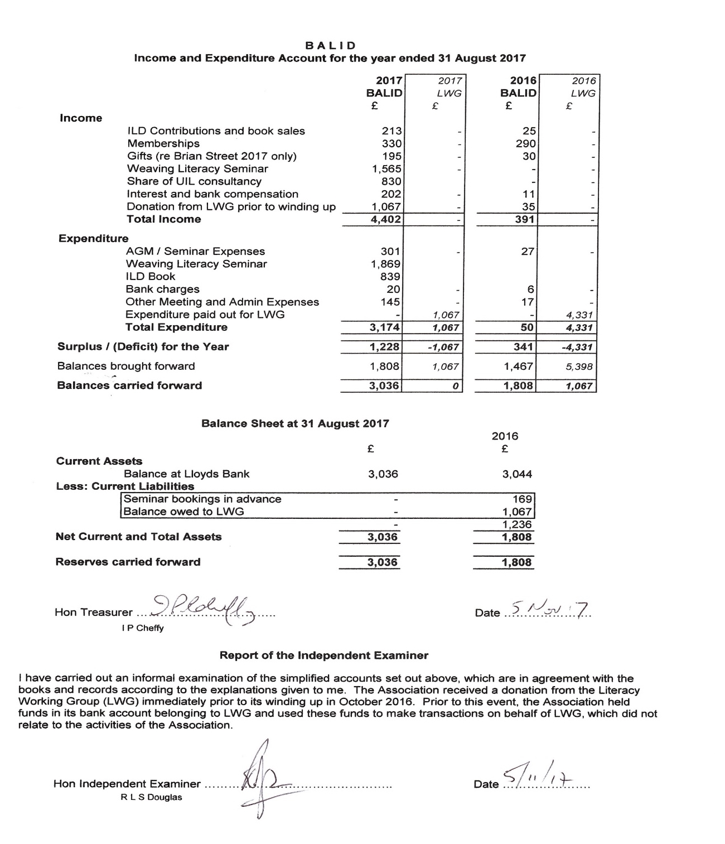

# Informal Literacy Discussions (ILDs) 2016 -2017

A very important part of BALID’s contribution to the field of literacy is our regular programme of Informal Literacy Discussions. We have held five of these over the past year.

**ILD 24: Professional Communication and Client Care: literacy implications for vocational and professional adult education**. This was the title of Tara Furlong's paper for a discussion about the higher levels of literacy needed for professional communication. (November 2016)

**ILD 25:** **Training Literacy Facilitators in Central Tanzania:**  Margaret Beckett of SIL led this discussion, which focused on the literacy programme she is involved with in rural Tanzania. People there speak many languages, and some may also have a knowledge of Swahili. As a sub-title, Margaret used the memorable phrase 'Culture eats strategy for breakfast', thus effectively emphasising how important it is to understand and appreciate local voices and local values.  (January 2017)

**ILD 26: Literacy in Northern Nigeria:** Mary Anderson led this discussion, basing her input on her experience training teachers on the DfID-funded Teacher Development Programme. Areas of concern include the literacy levels of teachers, and the tensions between the Islamic and western educational systems. The following reflections focused on the role of the electronic media, and whether more use could be made of locally-produced materials rather than books published by commercial companies. (April 2017)

**ILD 27: Learner-generated materials, collective classroom knowledge: Research with adult literacy facilitators in Guatemala:**In this fascinating seminar, Marta Paluch of the University of Sussex shared her experience of working with adult literacy facilitators, and the process of collective construction of knowledge. Marta also included a very helpful PowerPoint presentation to illustrate the discussion. (June 2017)

Details of these events can be found on the BALID website (www.balid.org.uk), and all upcoming events are posted on our BALID Facebook page.

*Mary Anderson*

# BALID day seminar, 18th November 2016

at the UCL Institute of Education, London



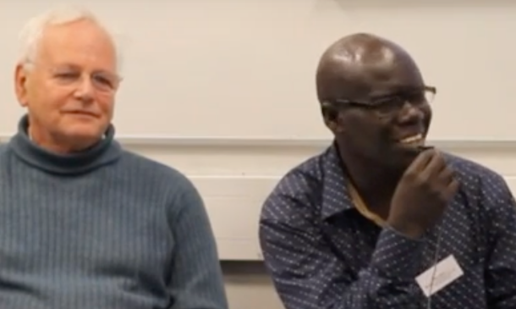This all-day seminar was chaired by Professor Alan Tuckett, past president of the International Council for Adult Education, and it revealed the strength and depth of BALID’s work. Our keynote speaker was Dr Ulrike Hanemann from UNESCO’s UIL in Hamburg, and we then had input from four panellists.

Firstly, Dr Willy Ngaka of Makerere University, Uganda, (pictured, with Alan Tuckett) presented on volunteer-led informal community literacy initiatives, where the challenges include a culture of monetisation.

Albha Bowe from Feed the Minds then described two large projects with the National Rural Development Program (NRDP), a partner NGO in Pakistan aiming to improve maternal and child health in Sindh and Narrowal, two districts with high levels of poverty.

Professor Martha Young-Scholten of Newcastle University, UK, introduced three projects aimed at adult immigrants who fit under the category of Low-educated Second Language and Literacy Acquisition (LESLLA) for Adults.

The last panellist was Lesley Waller who presented Africa Educational Trust's cross-generational literacy projects in West Nile province, Northern Uganda, and among the Maasai in North Central Kenya.

These provided a helpful backdrop for our small-group discussions, which proved very fruitful, with much inter-disciplinary and international learning. We are really grateful for all the richness of insights that we gained.

Feedback on the day was very positive indeed, with many commenting on the wide-ranging dialogue and the encouragement of flexibility and creativity in the adult literacy field. Participants emphasised the value of the opportunities for group work, as well as appreciating the quality of the four case-study presentations. Several participants commented that they would be looking at further means to integrate literacy development into projects, ranging from participatory approaches to curriculum and resource development to amplifying literate environments drawing on local contexts.

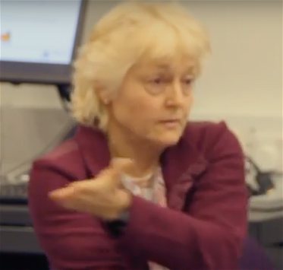In conclusion,Dr Ulrike Hanemann (pictured) highlighted the diversity of literacy practices, and that literacy is beginning to be seen as a continuum of knowledge and skills embedded into local contexts. This is more so as literacy is integrated into three-dimensional lifelong, lifewide and systemically and politically life-deep processes of learning. These necessarily implicate forms of measurement and evaluation. Beyond the call for basic adult education as a human right and basis for economic development, lifelong literacy touches on health, community development and digital accessibility and inclusion.

A full report on the seminar can be found on the BALID website.

*Mary Anderson*

# Committee Members 2016 – 2017

**Chair: Dr. Katy Newell- Jones**

Katy wasformerly Programme Director of Feed the Minds and is now a consultant in learning and teaching with a strong focus on literacy in development. She started as a basic skills tutor and trainer of trainers in the UK in the early 1980s. Since 1992, Katy has been involved in supporting capacity building of a range of non-governmental organisations (NGOs) overseas, during which she developed a strong interest in the role of literacy in post-conflict and other challenging contexts. In recent years, her interest has been on embedding literacy into community development projects, ranging from maternal health projects in Nepal and Pakistan to land rights, vocational training and agricultural extension projects in Rwanda.

**Secretary: Dr. Juliet McCaffery**

Juliet specializes in literacy, gender and equalities. She worked in schools and adult literacy in the US, Brighton and London and then as gender officer at the British Council. On leaving the British Council she became an international consultant. She trained literacy facilitators, designed and evaluated literacy and education programmes in Sub-Saharan Africa, the Middle East and Indian sub-continent. She became interested in English Gypsies and Irish Travellers as an elected Councillor and undertook research for her PhD on their attitude towards education. Her research interests are literacy and education in marginalized communities.

**Treasurer: Dr. Ian Cheffy**

Ian isa Literacy and Education Consultant with SIL International, the NGO which develops writing systems for communities speaking previously unwritten languages so that they can use their languages for their own education and development.

He worked in Cameroon for ten years until 1999 but is now based in the UK. He is currently undertaking a research project in five African countries exploring the changes which have come about in the lives of individuals and their communities as a result of literacy in local languages. His PhD explored the meanings of literacy for people in a language community in northern Cameroon.

**Dr. Mary Anderson**

Mary is a linguist with a special interest in Nigeria and West Africa. She has worked for many years in language-teaching publishing, both as a commissioning editor and as a writer. More recently she has become involved with developing materials for teaching basic literacy skills in non-European languages.

**Tara Furlong**

Tara has twenty years’ experience in adult education and training in the private and public sectors in the UK and abroad, specialising in integrated English language, literacies and digital learning. She is involved in delivering professional development via national organisations in the UK, and publication work; and has an established history of designing and implementing systemic curriculum quality initiatives in education providers. Tara has an ongoing interest in the relationship between multi-modal and contextualised versus abstracted learning; its mirror in social and literate practice and language across life spheres; and the function of storytelling in co-ordinating action. As well as work with Designing Futures Ltd, Tara does pro bono work for RaPAL, BALID, and is an active local school governor.

**Prof. Alan Rogers**

Alan is an adult educator with research and training interests in adult learning and teaching.  He has worked widely as a practitioner in the training of teachers in adult literacy and basic education, especially in countries of Africa and Asia. He recently completed a review of the Folk Development Colleges in Tanzania (with the assistance of Sida) and is currently working on projects in Ethiopia and Afghanistan.  A Visiting Professor at the universities of East Anglia and Nottingham, he has written extensively in these fields.  He is currently co-editing a book of essays, of which Brian Street was co-editor, on numeracy as social practice to be published shortly by Routledge.

**Prof. Brian Street**

Brian undertook anthropological field work in Iran during the 1970s, from which he developed theoretical approaches to literacy in cross-cultural perspective. He then taught social anthropology at Sussex University for 20+ years, ultimately becoming Professor Emeritus of Language in Education at King’s College, London. He has written and lectured extensively on literacy practices from both a theoretical and an applied perspective. He has a longstanding commitment to linking ethnographic-style research on the cultural dimension of language and literacy, with contemporary practice in education and in development. He has over 30 publications**.**

# Publications by Committee Members 2016-2017

(committee members’ names in **bold)**

**Anderson,** M.(2017) ’Literacy Publishing for Northern Nigeria’. *Theory and Practice in Literacy and Development: Papers from the BALID Informal Literacy Discussions.* Uppingham Press.

**Cheffy,** I.(2017) **‘**Transferable Literacies: To what Extent Do Literacy Practices taught as Social Practices Result in Transferable Literacy Skills’. *Theory and Practice in Literacy and Development: Papers from the BALID Informal Literacy Discussions.* Uppingham Press.

Aikman, S., Robinson-Pant, A., McGrath, S., Jere, C., **Cheffy, I.**, Themelis, S., & **Rogers, A.** (2016) ‘Challenging deficit discourses in international education and development,’ *Compare* 46 (2)

**Cheffy, I., McCaffery, J. & Street, B.** (2017) ‘Promoting literacy from the UK: The contribution of the British Association for Literacy in Development (BALID)’, *Prospects*Available from: http://link.springer.com/10.1007/s11125-017-9402-0

**Cheffy, I.** & Trudell, J. (2017) ‘”We Also Wanted to Learn”: Narratives of Change from Adults Literate in African Languages’, *International Review of Education* Available from: http://link.springer.com/10.1007/s11159-017-9664-z

**Furlong,** T. (2016) 'Lifelong Literacy for all', *RaPAL Journal* Vol. 89 pp.26-29.

**Furlong**, T. (2017) *Educators’ literacy practices associated with research-engaged andragogy contribute significantly to improving learning outcomes: implications for leadership.* MBA in Educational Leadership (International) Thesis, UCL IoE (University College London Institute of Education)

**Furlong,** T. & Yasukawa, K. (Eds.) (2016) *Resilience: Stories of Adult Learning.* UK and Australia: RaPAL and ACAL

Hanemann, U., **McCaffery, J. Newell-Jones, K.** & Scarpino, C.(2017)*Learning Together Across Generations: Guidelines for Family Literacy and Learning Programmes for Lifelong Learning*. UNESCO Institute for Lifelong Learning Available from http://unesdoc.unesco.org/images/0024/002484/248446E.pdf

**McCaffery,** J. (2017) ‘Western Education: Suitable for Everyone? Education for travelling marginalised and indigenous communities in the West’, *Prospects* Available fromhttps://doi.org/10.1007/s11125-017-9413-x

**McCaffery, J.** & **Street,** **B.V.** (Eds). (2016) *Theory and Practice in Literacy and Development: Papers from the BALID Informal Literacy Discussions 2011-2015.* Uppingham Press

**Rogers, A.** (2016) ‘Review of *Livelihoods and Learning: Education for All and the Marginalisation of Mobile Pastoralists.* *By Caroline Dyer. London: Routledge, 2014*’ *Social Inclusion* 4(1) pp 42-43

**Rogers, A.** & **Street,** **B.V.** (Eds.) (2017) ‘Learning to Read from a Social Practice View:

Ethnography, Schooling and Adult Learning’ *Prospects* Available from <https://link.springer.com/content/pdf/10.1007%2Fs11125-017-9411-z.pdf>

Warkineh, T. Z., **Rogers, A.** & Danki, T. N. (2017) ‘Profiling adult literacy facilitators in development contexts: An ethnographic study in Ethiopia’, *International Review of Education* (E-pub ahead of print)

**Street,** **B.V.** (2017) ‘New Literacies, New Times: Developments in LiteracyStudies’ in **Street, B.V**. & May, S (eds) *Literacies and Language Education*, pp.3-15.

### **Street,** B.V. **(**2016) ‘Literacy and Development: Ethnographic Perspectives’ - The Ramphal...www.ramph.alinstitute.org/uploads/.../literacy_and_development

Castanheira, M.L. & **Street, B.V. (**2017) ‘Literacy in and out of School in a Brazilian Bairro: Implications for Policy. *Theory and Practice in Literacy and Development’ Papers from the BALID Informal Literacy Discussions.* Uppingham Press.

# Organisational partners of BALID

### Feed the Minds is an adult education charity. Since 1965, their community education projects have helped people to overcome problems such as poverty, poor health, conflict and discrimination. Feed the Minds has Christian roots but they work with people of all faiths and people with no faith. Across the world, they run practical education projects with local partners, and their projects help marginalised adults to gain knowledge, skills and confidence that transforms their lives. Based on local needs, each project covers at least one of these three themes: Health Education, Citizenship and Economic Empowerment. Feed the Minds’ vision is for a world in which all people everywhere have the opportunity to live life in all its fullness.

### BALID has particularly appreciated the contribution of Feed the Minds in the form of providing meeting space free of charge, as well as a physical address for correspondence.

### Find outmore at:www.feedtheminds.org .

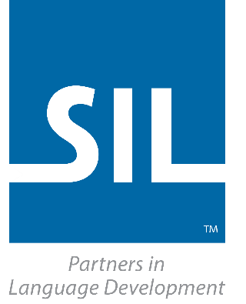

SIL International is a faith-based nonprofit organization committed to serving language communities worldwide as they build capacity for sustainable language development. SIL does this primarily through research, translation, training and materials development. SIL works alongside ethnolinguistic communities and their partners as they discover how language development addresses the challenging areas of their daily lives—social, cultural, political, economic and spiritual.

SIL supports BALID actively through formally allowing Dr Ian Cheffy time to act as the BALID treasurer.

Find out more at: www.sil.org .

BALID also works very closely with RAPAL

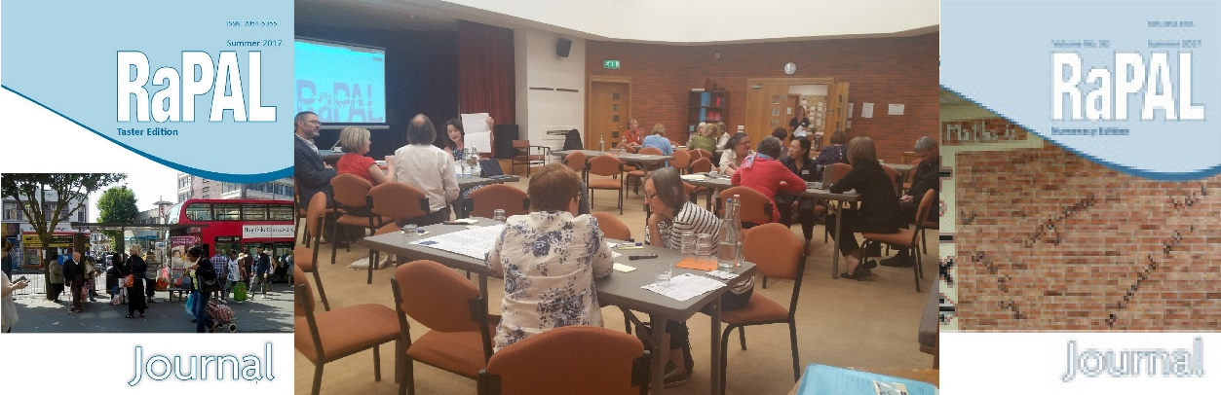

Research and Practice in Adult Literacies (RaPAL) is the only UK-wide organisation that focuses on the role of literacies in adult life. It promotes effective and innovative practices in adult literacies teaching, learning and research; and supports adult literacies practitioners and researchers through its members, digital journals, conferences and fora, and policy and advocacy work. It is active in Europe and has international links. While not (yet) an organisational member, it works increasingly closely with BALID.

Find out more at: www.rapal.org.uk .

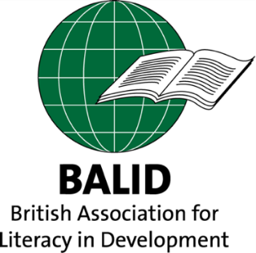

**BALID** is a non-governmental organisation (NGO) promoting adult and family literacy and numeracy as a basic human right, in the context of development.

As a member organisation, BALID brings together individuals and organisations who believe that sharing experience about learning and literacy can help enrich workers and citizens in both the industrial and the developing world.

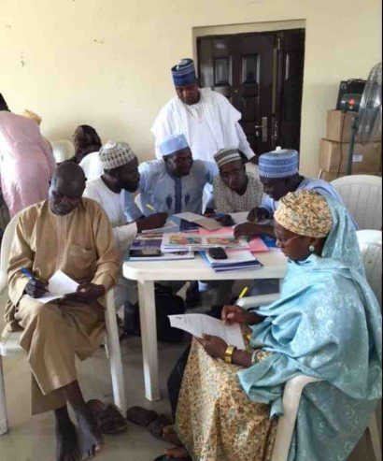

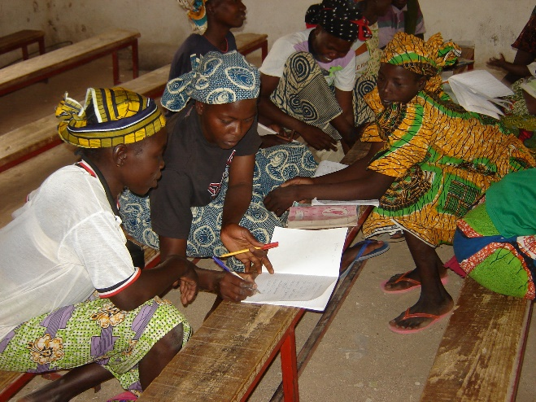 Northern Nigeria (photo: Mary Anderson) Cameroon (photo: Ian Cheffy)