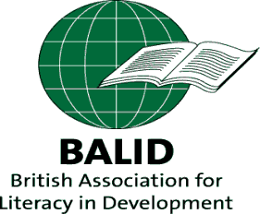
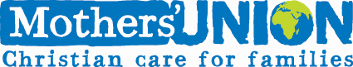

Community transformation
through literacy and numeracy education

Nicola Lawrence, Head of International Programmes, Mothers’ Union
31st October 2013

Mothers’ Union is an international faith based organisation, rooted in the Anglican Church, and working in 83 different countries. It has over four million members, mainly in the developing world, each demonstrating their Christian faith in action by the transformation of communities worldwide. Mothers’ Union are working with people of all faiths and none in 83 countries to promote stable marriage, family life and the protection of children through praying, enabling and campaigning.

In 2000, Mothers’ Union introduced a literacy programme in response to calls from its members around the world to help women and men become literate and numerate so that they would then be equipped to address their other issues and concerns. Literacy and numeracy were seen as the gateway towards long-term development and empowerment of individuals, families and communities.

“Literacy is not just reading and writing but the ability to write one’s life
and read one’s reality” Paulo Freire, 1985

Overview

Mothers' Union's Literacy & Financial Education Programme is designed to give a holistic approach to empowering some of the most marginalised communities in the world, meeting millennium development goals of reducing poverty, increasing the participation of women and girls in education and employment, tackling HIV/AIDS and improving family health. The programme uses participatory methods to enable communities to acquire basic literacy and numeracy skills whilst discussing and planning action on their daily issues and challenges. In addition, through the partnership of Mothers’ Union with Five Talents, the programme also specifically focuses on building knowledge and skills in business development and community savings group formation for its members. As a result women are now gaining financial independence, have more autonomy to manage their lives and are participating in household decision-making as well as community politics and leadership.

Community volunteers are trained as literacy facilitators, who are then equipped to run literacy circles in their own community. All literacy circles and savings groups are open to everyone, crossing the boundaries of religion, age, gender or tribe enabling community cohesion, unity and empowerment. The programme has been especially effective in reaching those who are the most marginalised in society including groups previously discriminated against such as the Twa pygmy tribe in Burundi and displaced communities in Ethiopia, Sudan and South Sudan.

How it works

Step 1:
The programme aims to bring gender – sensitive literacy and numeracy skills to the poorest and most marginalized areas. Through a sensitisation process, Mothers’ Union Trainers undertake community needs assessments and invite communities to join the programme and set up a literacy circle. This involves talking to community Chiefs, local religious leaders and the community as a whole, explaining what Mothers’ Union is offering through this programme and inviting them to be part of the programme. They can decide not to join the programme and that has happened in some cases. Mothers’ Union has found that this initial sensitisation phase is essential in securing community ownership and promotion of the programme, as well as avoiding misunderstandings and disappointment if expectations are not clear from the beginning.

Communities that do wish to proceed are encouraged to form a local steering committee. The role of the steering committee is to provide support and advice for learners. The committee is also involved in conflict management, planning, monitoring and marketing the programme, and encouraging new learners to participate. In some cases, they also provide shelter and learning materials if in short supply. The programme is therefore owned by the community, rather than being seen as an external programme being brought in by outsiders.

Step 2:
The local steering committees, together with the Mothers’ Union Trainers, are responsible for selecting an appropriate person to become the literacy circle facilitator from the community. These facilitators are literate volunteers who are trained in group formation and development as well as developing literacy and numeracy skills in a participatory way. Once trained, they proceed to form literacy circles and begin the programme activities.

Anyone who is illiterate is accepted within a circle, though the programme actively encourages women to participate and to form around 70% of learners. Facilitators are expected to give several hours a week to working with their circles. On average, there are around 20-25 adults within a literacy circle and the circles meet 2-3 times a week for approximately two hours each time. The first step within each circle is to talk about the development issues important to the learners and then to develop skills in literacy and numeracy around these issues. Depending on the speed of the learners, the participants within a circle can be accredited as literate and numerate within one - two years. In Burundi, accreditation is recognized by the national government.

The programme is based on a participatory model of development. There are no pre- printed text books or rote learning used in this approach as literacy is not just a skill but a process. The process of literacy is linked with the process of social change where the ‘teacher’ becomes a facilitator, enabling the learning process to develop according to the needs of the learners. Each literacy circle develops their own learning materials through discussion, drama, stories, dance or the joint construction of maps, charts, calendars and diagrams that represent their local situation. In the process, learners build their own self-confidence, acquire new skills and the ability to make decisions and organize themselves.
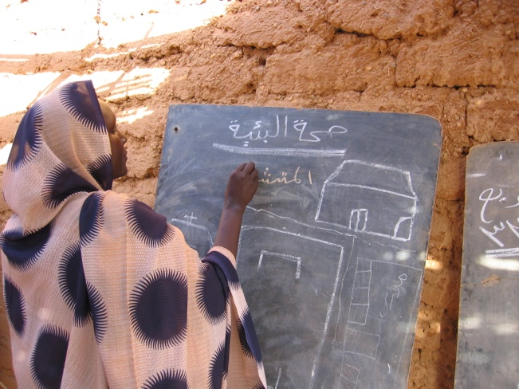
Groups talk about issues that affect them in their daily lives – water for example. They may talk about the taps in the community and begin to learn how to write the words. They might draw on a map where the taps are in the community, count them and then count how many are broken. This might lead to further action on what they can do to mend the taps. The discussion aspect helps generate self awareness of their community and create a catalyst for change.

Step 3:
Once participants within a circle have reached the stage of becoming accredited literate and numerate, they usually choose to continue to meet in order to engage in activities that they have identified within the learning process. Mothers’ Union’s partnership with Five Talents - which specialises in financial education - has helped strengthen the programme and means that the journey of discovery and opportunity for learners continues beyond receiving their accreditation certificate.

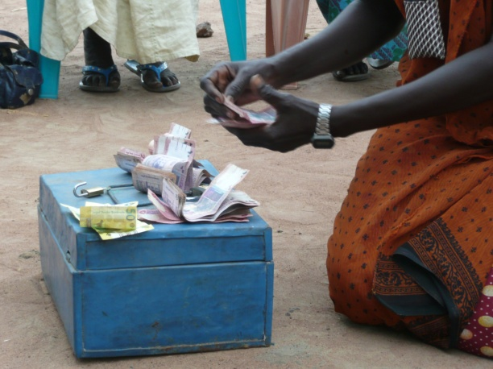
Once literate, men and women can be further equipped to take steps towards economic empowerment through training on the formation of 'accumulated savings and credit groups' which enable groups to mobilise their own savings and lend to each other.

The facilitators are given additional training in budgeting, saving, borrowing and basic business skills, and encouraging local informal banking in the community. The facilitator then introduces the group on how to save money and make loans to each other. Participants within the group decide themselves on the percentage of interest and any fees they wish to charge. They also write their own constitution and conditions of saving and loans.

Participants are provided with a safe place to save on a flexible basis. Women have access to larger lump sums of money, which can be used towards business expansion, purchase of productive assets, or in times of emergency. Many savings groups eventually open bank accounts.

The loans and saving scheme and training in budgeting enable many group participants to expand on existing businesses or develop new ones. Most of the small businesses that are started tend to be agriculture based - trading in tomatoes and plants, growing cabbages and vegetables, and selling agricultural produce in markets. Others involve opening small restaurants, and making and selling handcrafts. Increased business activities result in higher and more stable income for many of the families participating in the programme.

Impact

Through this programme Mothers’ Union has helped over 130,000 men and women become literate and numerate and new people continue to join the programme each day. Each learner is also part of a family and a community, and the impact of the programme can be felt far wider than just an individual.

Literacy and numeracy have everyday applications – counting the right change at the market, getting on the right bus, reading dosages on a medicine bottle. But the impact of literacy and numeracy goes way beyond this – drastically changing families and communities. For example, more children, especially girls, are going to school now because of how the learners now feel how important an education is to boys and girls.

“When I paid and received the change I didn’t understand why sometimes I would only get one note back. People would laugh at me. Now things are different because of this programme, if my husband gives me money I know how it is and what change I need to get.” Celina, Juba, South Sudan

There is increased awareness of hygiene and sanitation, health and vaccinations which is helping reduce infant and maternal mortality. Harmful traditional practices such as Female Genital Mutilation are also being stopped because of the programme.

Gender attitudes have changed
One of the main developments of the programme has been the change in gender attitudes. With accredited learners now undertaking income generating activities and increasing their household incomes, the programme is also helping to ensure that women and female learners in particular are able to participate in the financial decision making of their homes and communities. The programme challenges the preconceived notion that women should not or cannot participate in anything concerning money.

Husbands and male family members are now taking care of their children and playing a more active role in their well-being. This change is so key as boys now have positive role models in their fathers and are receiving the love and attention that they so craved.

“We used to work as individuals but we have learnt to work together as a group. We also talk to our wives ‘properly’. I have started working with my wife and I have seen a big change. Nowadays, when my wife goes to the market to sell milk, I remain at home taking care of the children.” Gabriel, a male learner in Malakon cattle camp, South Sudan

The programme also introduces participants to advocacy, with the aim of increasing beneficiaries’ awareness of advocacy and women’s rights at local, national and international levels. Female and male learners are now more aware of women’s rights. This is such an important issue raised in most literacy circle discussions. Before the programme the majority of women when widowed were often left stranded without land or inheritance rights as in-laws and other relatives drove them off their land. Now women are aware of their rights and know where to seek help if they are abused.

Another outcome of the programme is that relationships between men and women, and also between parents and children are being healed, strengthened and restored.

“Before we joined the literacy circle we were always quarrelling because I thought that my wife was worthless. I never consulted her in any decision-making, and used a lot of money to buy drink. I regularly beat my wife and forbade her to participate in community meetings or undertake any income generating activities. Our family was very poor and troubled.

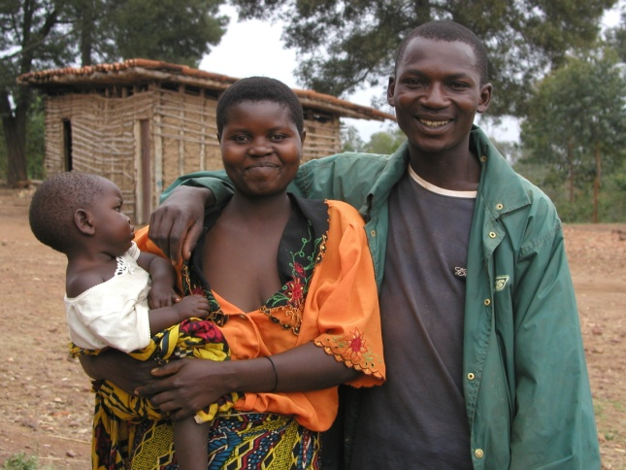
But when we joined the literacy circle, our family life changed. Through various discussions with other learners, I discovered that women are not worthless. I discovered that they have many talents and skills and that they can take wise decisions. So I started to involve my wife in making decisions and now even the income of the family has increased. I have also given up drinking because I have come to realise how bad it is after discussing this issue with other learners.

Now our family is happy. We are now literate and can do small business without being cheated in the market. I want to encourage my wife to stand for the next election as a leader of our community”. Deo, Gitega, Burundi

New developments

Awaken is a Mothers’ Union resource that takes individuals, families and communities on a journey of community transformation through literacy.

Awaken is a development of the Church and Community Mobilisation Process (CCMP) approach which helps churches and Mothers’ Union groups develop their own potential to tackle issues of poverty using the resources they already have. The aim of CCMP is to bring about transformation for communities without constant reliance on external aid. However, from its experience of working in communities across the world, Mothers’ Union identified a potential barrier for those who are illiterate being able to fully participate in CCMP. This means large numbers of people still cannot benefit from the training or participate in the process and remain dependent upon external aid and resources.

Mothers’ Union, working together with Tearfund and other partners, has developed the Awaken resource in order to combine the CCMP approach with the Literacy & Financial Education Programme methodology. In this way Mothers’ Union hope to enable illiterate people to not only become literate, empowered individuals, but also to equip them to play a key role in shaping and changing their communities for the better.

Discussion

Following the presentation, there was a discussion around the issues raised. These are just a few of the observations/questions which were raised and discussed:

- The challenge of different levels of literacy within a community and everyone learning at different rates and how this is managed within the programme. It was shared that in some communities where the Mothers’ Union programme is operating several groups have been formed in recognition that there are different levels of literacy within the community.

- The programme helps individuals become literate and numerate in their own language. Is there a recognisable point that people reach at which they begin to start thinking about other languages? It was shared that in some communities where the Mothers’ Union programme is operating learners have wanted to move on to English and/or other languages once they have become literate and numerate in their own language. This varies by community. Some learners have enrolled in government education classes or university courses after being in the Mothers’ Union programme to further their learning.

- Ethnography and languages which are not written down, and opportunities for literacy.

- Stakeholder involvement in the programme through the steering committees and community ownership was highlighted as a positive aspect, as well as the apparent harmony within the programme between input from inside and outside the community.

