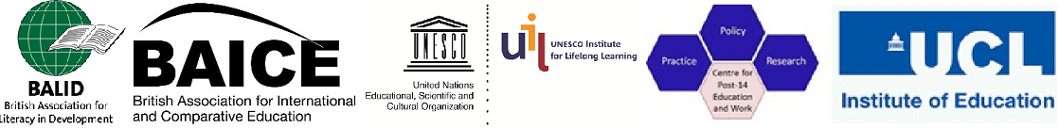
Weaving literacy through lifelong learning
Friday November 18th 2016
Venue
Institute of Education, Central London (10 mins walk from Euston Station)

Aim
To provide a forum for multi-sectoral dialogue exploring the role of literacy in enhancing lifelong learning

Background
The keynote speaker is Dr Ulrike Hanemann, UNESCO Institute for Lifelong Learning (UIL) on ‘Promoting lifelong learning: incorporating multi-sector approaches to literacy’.
The seminar will be chaired by Prof Alan Tuckett, past president of the International Council for Adult Education.
This seminar is aimed at practitioners, academics, NGOs, students and policy makers in the fields of literacy and lifelong learning. It will provide a forum for multi-sectoral dialogue exploring the role of literacy in enhancing lifelong learning.
In international education thinking, the concept of lifelong learning is well established, focusing on the promotion of learning opportunities of varied kinds for people of all ages with a view to unlocking their potential to live fulfilled lives as individuals and as members of their societies. However, much work remains to be done to develop a full understanding of how literacy is located within lifelong learning - a task which is complicated by the dominance of the traditional concept of literacy learning as involving only the mastery of basic reading and writing skills.
Through the day we will be exploring literacy within the context of international development agendas, especially the Education 2030 Framework for Action. There will be opportunities to hear examples of innovative practice from resource poor contexts and to take part in interactive sessions on the role of literacy in lifelong learning.
Weaving Literacy through Lifelong Learning builds on the series of events called Bridging the Gap, sponsored by the British Association for International and Comparative Education (BAICE), led by the Literacy Working Group and UEA’s Literacy Development Group, with the involvement of BALID. The final reports from these events are available on www.uea.ac.uk/education/research/areas/literacy-and-development/bridging-the-gap. BAICE is offering a small number of bursaries to students to participate in Weaving Literacy through Lifelong Learning – see below for details.

Outcomes
By the end of the day, you will have
- Explored locating literacy within the context of international policy development agendas, including Education 2030 Framework for Action
- Increased understanding of the underpinning role of literacy in enhancing lifelong learning
- Awareness of innovative practices from resource poor contexts
- Extended your network in the fields of lifelong learning and literacy

Programme
10.00 Coffee /tea available
10.30 Welcome and introductions
10.45 Introductory remarks from Alan Tuckett
11.00 Exploring the links between literacy and lifelong learning (group activity)
11.30 Plenary sharing key points
11.45 Promoting lifelong learning: incorporating multi-sector approaches to literacy with Ulrike Hanemann, UIL, UNESCO
12.30 Discussion and plenary
13.00 LUNCH
13.30 Implications in practice – a carousel of challenges from pre-event survey
14.00 Presentations of case studies / innovative thinking linking literacy and lifelong learning Including Africa Education Trust (AET)
14.45 Exploring implications for NGOs, HEIs and agencies
15.30 Plenary
16.00 Closing remarks Brian Street
16.15 Evaluation and finish

Audience
Practitioners, academics, NGOs, students and policy makers in the fields of literacy and lifelong learning.

Fee
Standard booking fee £80
Members fee (IoE or BALID) £60
Unwaged (inc. students) £30

Details of the event are available on the BALID website www.balid.org.uk or from Ian Cheffy on ian_cheffy@sil.org

Places can be booked through the UCL/IOE bookings system – click here for the direct link.
Bursaries for students
BAICE has provided funding for a small number of bursaries to participate in the Weaving Literacy through Lifelong Learning event. Bursaries will cover the event fee and up to £60 travel expenses for the event.
Applications for bursaries should include name, institute and course/programme of study, details of travel expenses to participate in Weaving Literacy and a brief explanation of how participating in the event will enhance your development.
Applications should be sent to Dr Ian Cheffy at ian_cheffy@sil.org by Monday 10th October 2016. Applicants will be informed as to whether they have been successful by Monday 17th October.
Successful bursary holders will be asked to write a short report 750-1,500 words on what they gained from participating in the event which will be used to report back to BAICE after the event.

